MEMO
From: Richard Rennehan, 0413101, IT Data Analytics
To: Bill Cunningham
Date: March 15, 2019

SUBJECT: SAP Practice Reports 13-21

Statement of Requirement
The purpose of this memo is to demonstrate solutions for SAP practice reports 13-21 to assist Global Bikes International (GBI) with operations.

Existing Materials
The 9 following practice reports are borrowed from the respective SAP document, pictured below. The data is borrowed from an Global Bikes Microsoft Excel file. The data contains information on bike sales and bike manufacturing in first-normal form. The data was imported into SAP Lumira Desktop for analysis.

In addition, this document will reference Bill Cunningham’s slides on visualizations. This will help analyze whether the visualizations follow best practices. 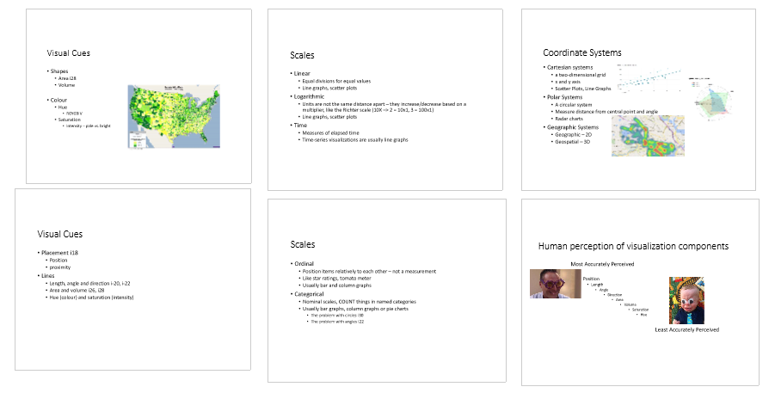
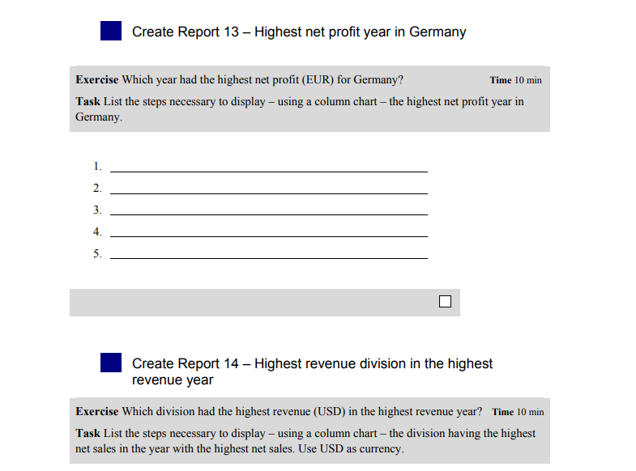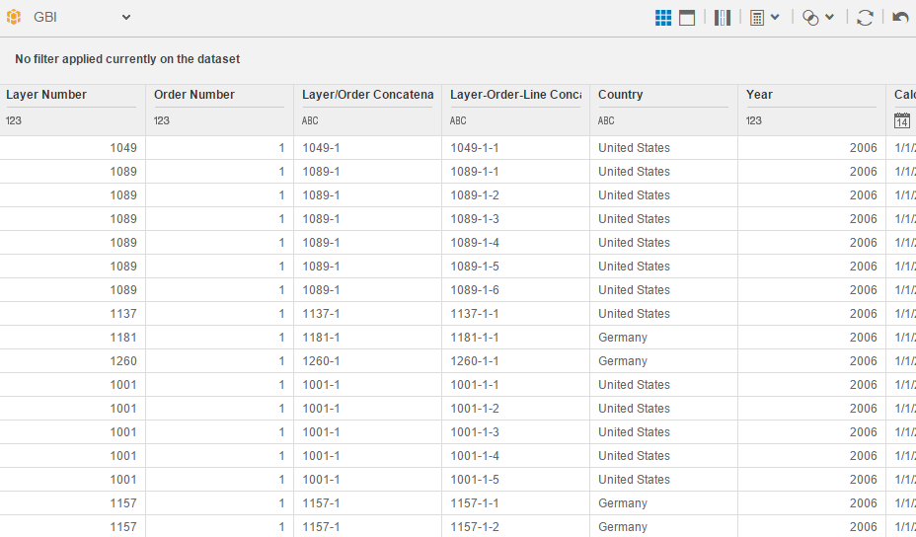
In addition, each document will reference the provided vizimpact and vizchoice diagrams to analyze the impact of the visualization and if it was the best choice.

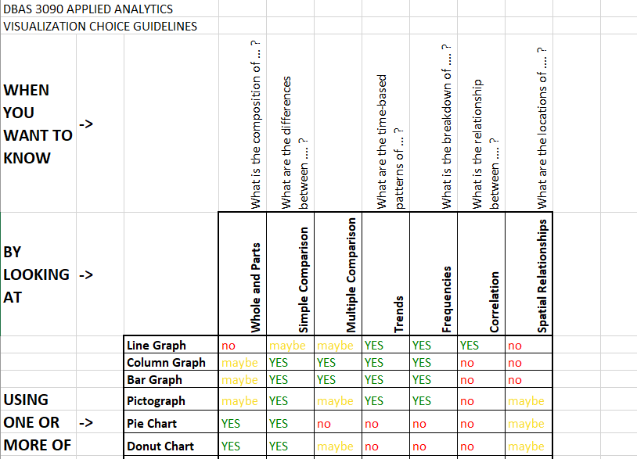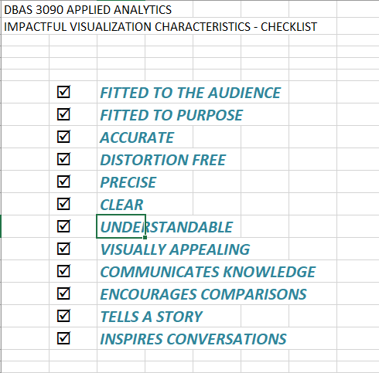

Reports 13-21

All 9 solutions will be written using the following structure:
- The request and its purpose
- Visualization type requested and data needed to complete the request
- Directions to complete the request
- The answer to the request (if applicable)
- Use of visual cues, scales, and coordinates
- Determining effectiveness of visualization through human perception of visualization components.

Report 13
SAP requests which year had the highest net profit (EUR) in Germany. This is the first step in helping GBI discover what makes for a successful year.

SAP requests use of a column chart. Here is the data required for the visualization:
- Year
- Country
- Profit Margin (EUR)

Follow these instructions to set up the visualization:
- Select column chart for visualization type
- Place Year and Country in the x-axis
- Place Profit Margin (EUR) in y-axis
- Filter Country so only Germany is represented

The year 2012 had the most profit for Germany.
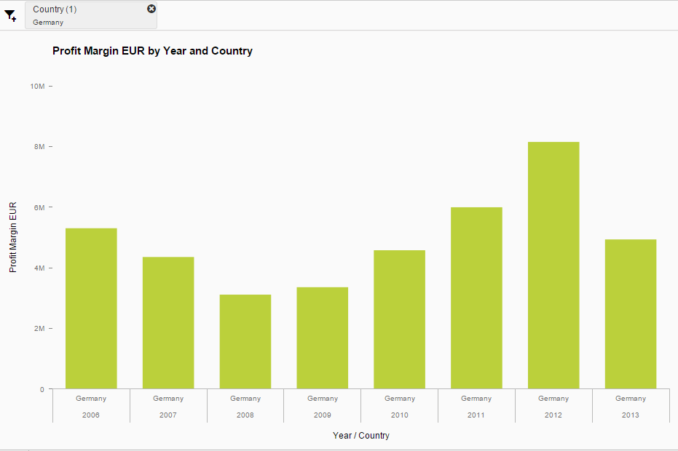
The visualization utilizes a linear scale and a categorical scale on a Cartesian System. It uses shape length as the primary visual cue. Column charts make sense when comparing the greatest value between a handful of categorical variables. Other visualizations used for comparing with an axis, such as radial column charts, may distort the results.

Length is the second top perceived visual element of visualizations, just behind position. This makes the visualization effective. Position could also be implemented by sorting from greatest to least. Because there are few comparisons and there are no close ties, seeing it form year to year is just as effective and has the added benefit of revealing the trend year to year.

Report 14
SAP requests which division had the highest revenue (USD) for the year with the most revenue. This is the first step in helping GBI determine what caused the division to perform so highly that year.

SAP requests use of a column chart. Here is the data required for the visualization:
- Year
- Division Description
- Revenue (USD)

Follow these instructions to set up the visualization:
- Select column chart for visualization type
- Place Year in the x-axis
- Place Revenue USD in the y-axis
- Place division description in columns
- Sort from greatest to least

The chart reveals that Bicycle sales in 2012 were the highest.
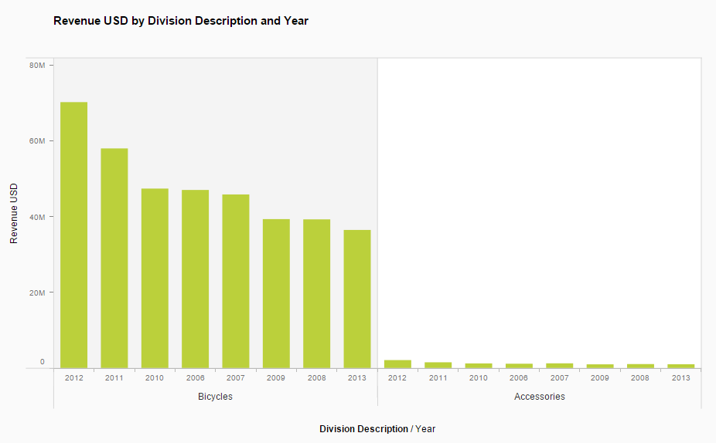
This visualization utilizes a linear scale and a categorical scale on a cartesian system. The visual elements implemented for interpretation are position and bar length/area. Column charts work well because we are comparing to identify the top value. I feel I could have done this more effectively by revealing that 2012 is the year with the most revenue with certainty. However, I was unable to figure out how to programmatically narrow results to the year with the most revenue.

Position and length are the top 2 perceived elements. This makes it easy to understand the graph.

Report 15
SAP requests which division had the lowest revenue (USD) in 2006. This is the first step in helping GBI determine what may cause unsuccessful division performance.

SAP requests use of a column chart. Here is the data required for the visualization:
- Year
- Sales Area Description
- Revenue (USD)

Follow these instructions to set up the visualization:
- Select column chart for visualization type
- Place Sales Area Description and Year in the x-axis
- Place Revenue (USD) in the y-axis
- Filter year to 2006 only
- Right click on visualization and enable data labels

Accessory sales in southern Germany brought in the least revenue in 2006.
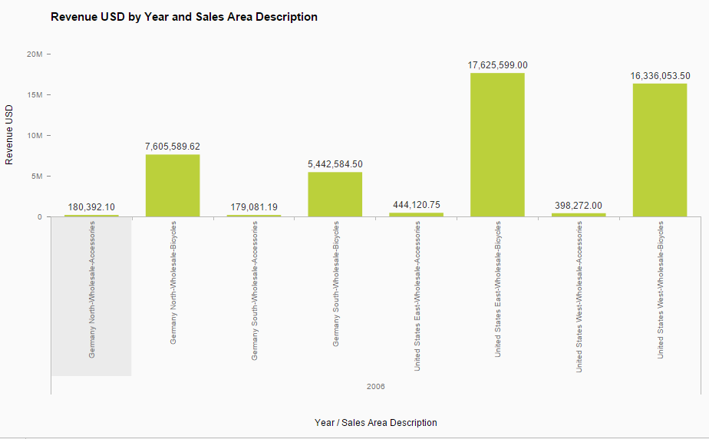s
This visualization utilizes a linear scale and a categorical scale on a cartesian system. The visual element implemented for interpretation is bar length. Column charts are very effective for comparing a value between categorical variables. They are easily interpreted.

Length is the second top perceived element of visualizations. This makes it easy to compare lengths of the bars to determine the lowest sales area. However, because the data values are very close and thus the lengths, I should have utilized the position element by ordering them from least to greatest. Here is a fixed version:

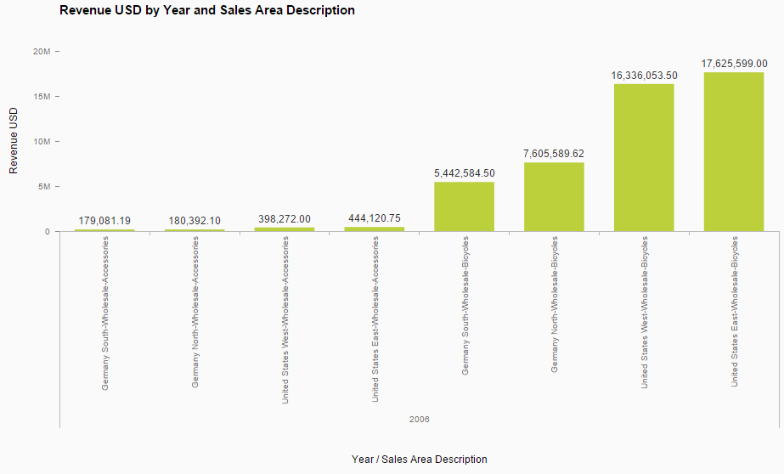

Report 16
SAP requests what is the total revenue (USD) for the top 3 customers for bikes in 2006. This helps GBI determine which customers have strong loyalty from the start of the data.

SAP requests use of a column chart. Here is the data required for the visualization:
- Year
- Customer Name
- Material Group Description (bikes)
- Revenue USD

Follow these instructions to set up the visualization:
- Select column chart for visualization type
- Place Year, Customer Name, and Material Group Description in the x-axis
- Place Revenue USD in the y-axis
- Filter Material Group Description to Finished Bikes
- Filter Year to 2006
- Place a top 3 ranking
- Add a custom calculation. Make it the sum of Revenue USD
- Right click and add data labels

The total among the top 3 customers for bikes in 2006 was $12,667,740.50.
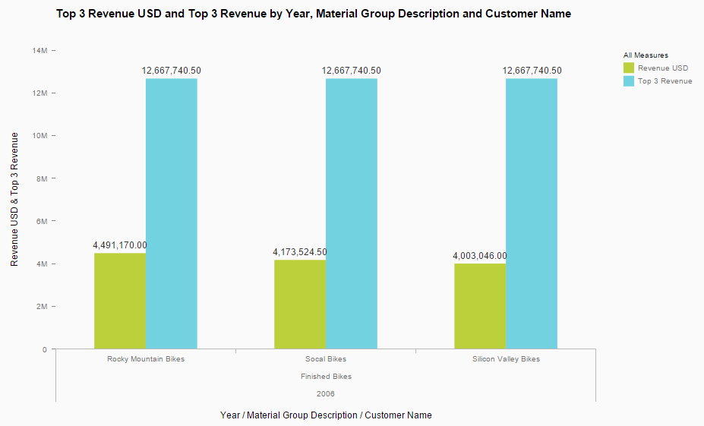
I was unable to figure out how to create the total revenue among the top 3 as its own category.

This visualization utilizes a linear scale and a categorical scale on a cartesian system. Visual elements implemented for interpretation are bar length and bar color. Column charts are very effective for comparing a value between categorical variables. They are easily interpreted.

Bar length is a very well interpreted component of visualizations. Color on the other hand, is the least well interpreted of all. To improve, I should ensure the two colors are distinguishable by different color-blindness types. I should utilize shading so even if the colors can’t be interpreted, the darkness of the bar can. Report 20 tackles this issue.

Report 17
SAP requests what year had the highest sales quantity and which year had the lowest sales quantity. This is the first step in helping GBI determine the difference between a successful year and an unsuccessful year.

SAP requests use of a column chart. Here is the data required for the visualization:
- Year
- Quantity

Follow these instructions to set up the visualization:
- Select column chart for visualization type
- Place Year in the x-axis
- Place Quantity in the y-axis
- Sort from greatest to least

The year 2012 had the greatest sales quantity while 2013 had the least.
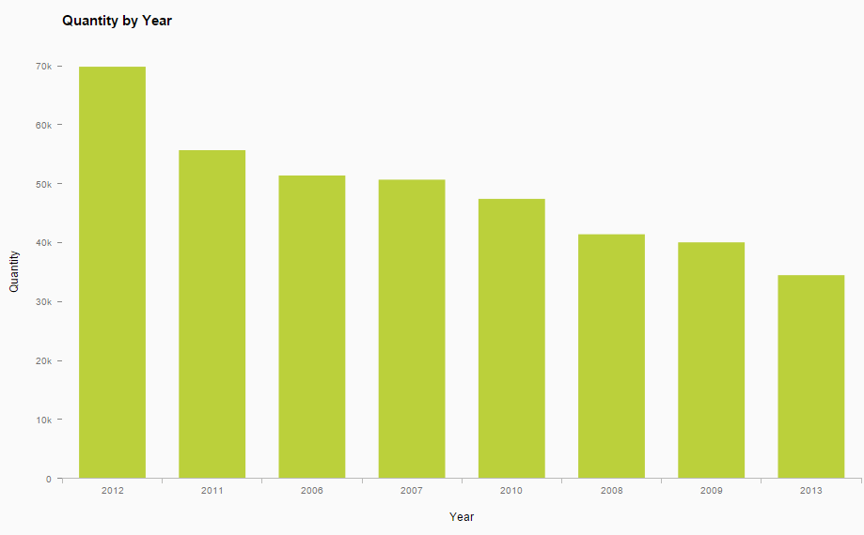
This visualization utilizes a linear scale and a categorical scale on a cartesian system. Visual elements implemented for interpretation are bar position and bar length. Column charts are very effective for comparing a value between categorical variables. They are easily interpreted.

I learned from my past mistakes with this one. Because GBI wants the top and bottom performing years, I sorted from greatest to least this time. This adds position and makes it effortless to determine the top and bottom years. Position and length are the top two best perceived elements of visualizations.

Report 18
SAP requests if GBI ever gained or lost a customer. This is the first step in helping GBI determine how to attract and maintain customer satisfaction.

SAP requests use of a line chart. Here is the data required for the visualization:
- Year
- Customer Name
- Revenue USD

Follow these instructions to set up the visualization:
- Select line chart as the visualization type
- Place Year in the x-axis
- Place Customer Name in rows
- Place Revenue USD in the y-axis

Scrolling down the list, we see that GBI lost DC Bikes, Motown Bikes, Red Light Bikes, and Silicon Valley Bikes. GBI never gained a new customer.
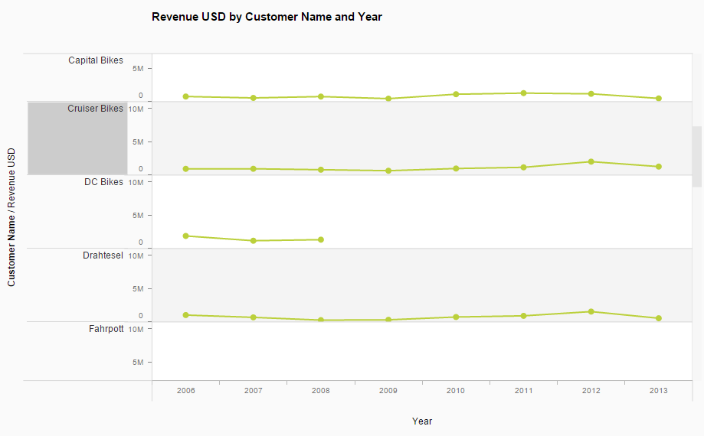
This visualization utilizes a linear scale and a categorical scale on a cartesian system. Visual elements implemented for interpretation are line length, line angle, and line direction. Line charts are effective for trends and are easy to interpret. Because we must scroll to see all customers, however, it makes it difficult to make comparisons. Adding interactive filtering will make it much easier to make comparisons. Here’s an example of an interactive solution:
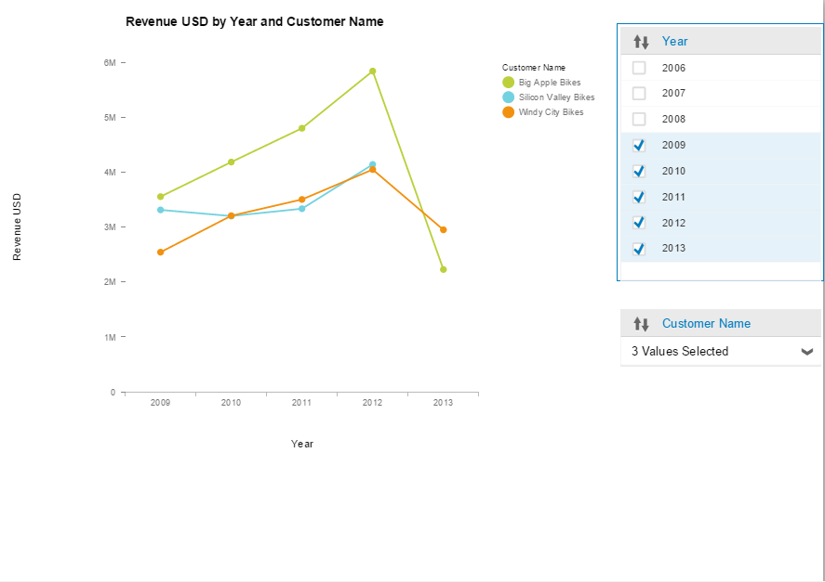
It’s easy to see which customers stopped supporting GBI. If the line disappears for good past a certain year, the company stopped supporting GBI. Line length is the second top perceived element of visualizations.

Report 19
SAP requests if there were any major changes in revenue (USD) during the eight years of the data. This is the first step in helping GBI understand areas of turnaround.

SAP requests use of a line chart. Here is the data required for the visualization:
- Year
- Revenue USD

Follow these instructions to set up the visualization:
- Select line chart for visualization type
- Place Year in the x-axis
- Place Revenue USD in the y-axis
- Add a difference from calculation on Revenue USD. This calculates the jump in revenue between years.

The following graph tells a story. GBI was on a downwards trend from 2007 to 2008. SAP recovered from the downwards trend in 2009. SAP turned the tables and started an upwards trend starting from 2009. From 2010 to 2012, the revenue was steadily inclining, and the future was looking bright. Finally, something may have went wrong in 2013 and GBI made almost 40 million dollars less than 2012.
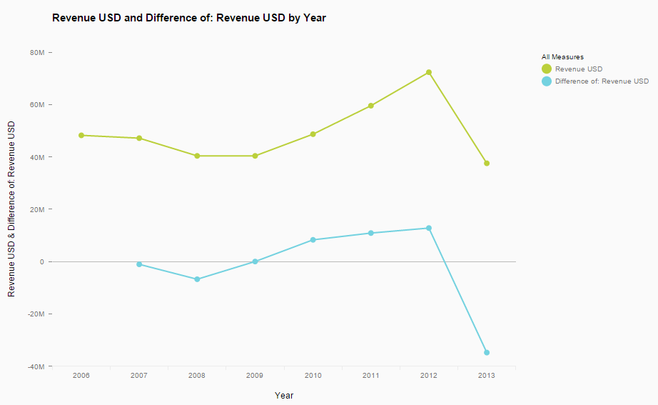
This visualization utilizes a linear scale and a categorical scale on a cartesian system. Visual elements implemented for interpretation are line direction, angle, and direction. This is a simple revenue over time trend, so a line chart elegantly displays its meaning.

Line angle and direction are the third and fourth best perceived elements respectively. Combined with this visualization’s minimalism, clarity, and ability to tell a story, this visualization is effective.

Report 20
SAP requests if there is seasonality in the revenue (USD) acquired over the last 8 years. SAP requests which month had the highest revenue and is the seasonality similar from year to year. Understanding seasonality will assist GBI with supply and demand.

SAP requests use of an area chart. Here is the data required for the visualization:
- Year
- Month
- Revenue USD

Follow these instructions to set up the visualization:
- Select area chart for visualization type. This is found under line chart.
- Place year and month under x-axis. Ensure year is above month
- Place Revenue USD in the y-axis.
- Place a running average on Revenue USD to identify the direction of the trend.
- Right click and show gridlines.

The appearance of many spikes reveals that seasonality exists in the data. Depending on the year, March, April, or October bring the most revenue.
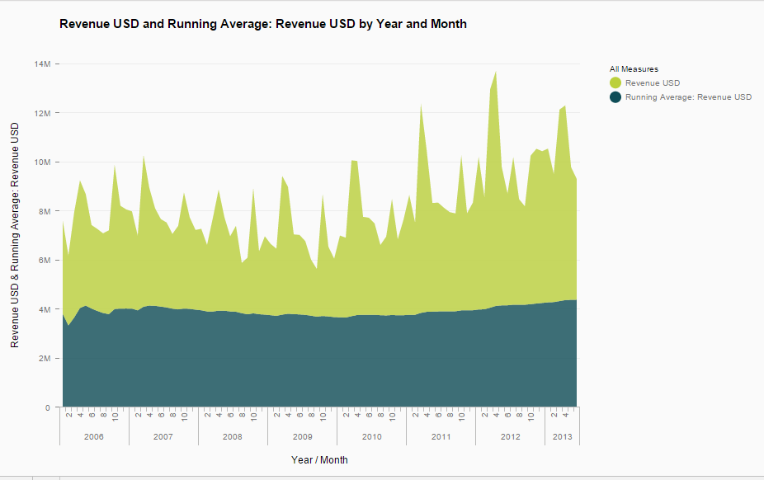
This visualization utilizes a linear scale and a categorical scale on a cartesian system. Visual elements implemented for interpretation are line direction, angle, area, saturation, and color. While the vizchoice document says to use area charts on a case to case basis, I believe it is the best choice here. With so many data points, using an area chart instead of a line chart makes it easier to gauge the information and see seasonality trends.

Because we have so many data points, it is effective to add interactivity. Here’s an example of displaying only data in 2009 to make it easier to identify the top month. The user can then hover over a datapoint with their mouse to reveal the month and its exact revenue.
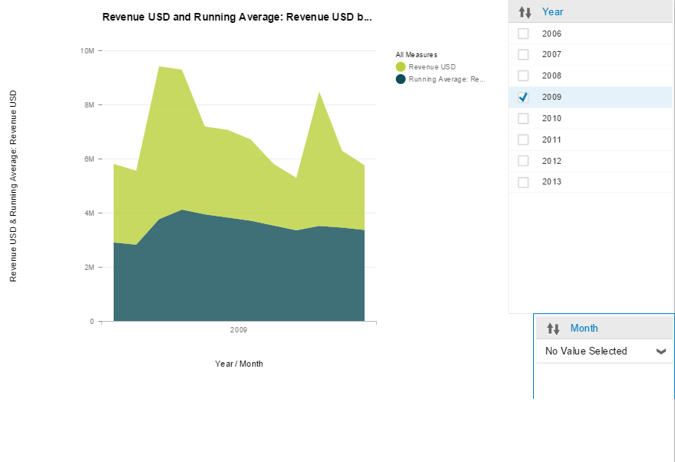

Direction, angle, and area are all at the upper half of the perceived elements diagram. This helps make the visualization more effective. This time, I made the second color darker to assist color-deficient people in identifying the difference.

Report 21
SAP requests which material had the lowest revenue (USD) in the year with the least revenue. This is the first step in helping GBI understand factors leading to lower sales.

SAP requests use of a column chart. Here is the data required for the visualization:
- Year
- Material Master Description
- Revenue USD

I find this is easier to understand with two visualizations. Follow these instructions to set up the visualization for the year with the lowest revenue:
- Select column chart for visualization type
- Place Year in the x-axis
- Place Revenue USD in the y-axis

We can see that 2013 had the least revenue.
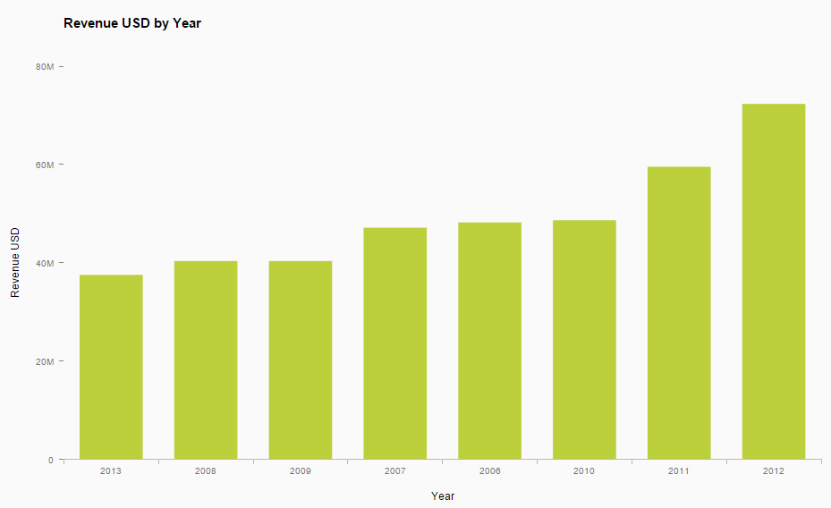
Follow these instructions to set up the visualization for the material with the least revenue:
- Select column chart for visualization type
- Place Year and Material Master Description in the x-axis.
- Place Revenue USD in the y-axis
- Filter Year to 2013 only, as it is the year with the least revenue
- Sort from least to greatest

The visualization reveals that the repair kit made the least revenue in 2013.
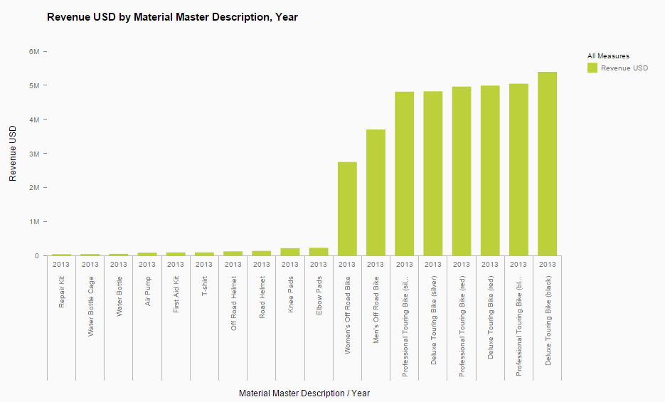
These visualizations utilize a linear scale and a categorical scale on a cartesian system. Visual elements implemented for interpretation are position and bar length/area. Column charts are effective for multiple comparisons and pinpointing greatest and least values.

This visualization utilizes position and length effectively. Position is especially important here because many materials have near identical values. Sorting from least to greatest instantly identifies which material made the least revenue, even though the bar lengths are almost the same.

